TERRA VISTA

**Your Gateway to Extraordinary Journeys**

Team Members

Supratim Maji

Parthib Majumdar

Tanmoy Bose

Shrija Mazumdar

Arjak Ghosh

**CONTENT** **Page No.**

1. ACKNOWLEDGEMENT 2
2. ABSTRACT 3
3. INTRODUCTION 4
4. OBJECTIVE  5
5. SYSTEM ARCHITECTURE 6-8

5.1 Frontend (React.js)

5.2 Backend (Node.js and Express.js)

5.3 Database Layer (MongoDB)

5.4 Data Flow and Communication

1. FEATURES 9-10

6.1 User Features

6.2 Admin Features

6.3 Security Features

6.4 Performance and Scalability

6.5 Cross-Device Compatibility

6.6 Future-Proof Architecture

1. SCREENSHOTS 11-15
2. CONCLUSION 16

## **ACKNOWLEDGEMENT**

We would like to convey our heartfelt gratitude to Prof. Ashok Gupta for his valuable advice and assistance in completing our project. He was there to assist us in every step. His motivation is what helped us to accomplish our task effectively. We would like to thank all the other supporting personnel who assisted us by supplying the equipment that was essential and vital, without which we would not have been able to perform efficiently on this project. We would like to thank Globsyn Summer Training School, Kolkata, for accepting our project. We would like to thank our friends as well as our parents for their support and encouragement as we worked on this assignment.

# **ABSTRACT**

TerraVista is a cutting-edge travel platform developed using the MERN stack (MongoDB, Express.js, React.js, Node.js), designed to enhance the way users explore and book travel experiences. The platform offers a user-friendly interface for browsing and detailed exploration of tour packages, alongside robust administrative tools for managing services and customer interactions.

Key features of TerraVista include a dynamic and responsive frontend built with React.js, secure user authentication using JWT, and comprehensive service management capabilities for administrators. The platform supports a full range of functionalities, from user login and signup to contact form submissions and tour management, ensuring a seamless experience for both travelers and admin users.

TerraVista’s architecture is designed for scalability and performance, leveraging MongoDB’s flexible schema and Node.js’s efficient processing to handle increasing data loads and user interactions. With a focus on security, user convenience, and future-proofing, TerraVista is well-positioned to adapt to evolving market demands and technological advancements, offering a reliable and engaging solution for the travel industry.

# **INTRODUCTION**

**TerraVista** is a modern tours and travel web application designed to revolutionize the way people discover and book travel experiences. In today's fast-paced world, travellers seek convenient, user-friendly platforms to explore destinations, plan trips, and make bookings effortlessly. TerraVista fulfils this need by offering an all-in-one solution, leveraging the power of the MERN stack—MongoDB, Express.js, React.js, and Node.js.

The platform caters to two main user groups: **travellers** and **administrators**.

* For travellers, TerraVista provides a sleek and intuitive interface, allowing users to browse through a wide range of tour packages, explore detailed itineraries, check availability, and make bookings—all from one convenient platform. With rich media support, including the ability to view images of destinations and services, TerraVista ensures that users get a comprehensive view of the experiences they are considering.
* On the administrative side, TerraVista offers a robust backend system for managing tour services. Admins can create, update, and delete services, upload images, and ensure that the information available to users is always up-to-date. The admin panel features a secure login system and various tools to handle service management efficiently, enabling seamless communication between the travel service provider and the end user.

Built on top of MongoDB for database management, Express.js and Node.js for the backend API, and React.js for the responsive frontend, TerraVista takes full advantage of modern web development practices. The use of the MERN stack ensures scalability, security, and performance, making the platform suitable for handling high traffic and data loads. This architecture also allows TerraVista to provide a smooth and responsive experience across different devices, whether it be a desktop, tablet, or smartphone.

In essence, TerraVista is more than just a travel booking website—it is a complete digital travel management solution aimed at enhancing the customer experience while providing administrators with the tools they need to effectively manage their services. The platform is designed with future growth in mind, ensuring it can scale to accommodate additional features like payment integration, user reviews, and more.

## **OBJECTIVE**

The primary objective of **TerraVista** is to create a seamless and efficient digital platform that enhances the way users explore and book travel experiences while empowering administrators with easy-to-use tools for service management. The project focuses on achieving the following key objectives:

* **User-Friendly Interface**: Develop an intuitive and visually appealing user interface that allows travellers to easily browse tour packages, view detailed itineraries, and make bookings with minimal effort. This includes user-friendly Login and Signup pages to facilitate secure account access and registration.
* **Efficient Service Management for Administrators**: Provide an admin dashboard that allows for the efficient management of travel services, including the creation, updating, and deletion of tour packages, as well as the ability to upload and manage images for each service.
* **Secure User Authentication**: Implement secure user authentication for both travellers and administrators. This includes robust Login and Signup functionalities that ensure data privacy and security. The system uses JSON Web Tokens (JWT) for secure login and session management.
* **Seamless Data Management**: Utilize MongoDB to manage and store user data, tour information, and booking details efficiently. This ensures quick retrieval and updates across the platform, supporting the smooth operation of Login and Signup processes.
* **Scalability and Performance**: Build the platform using the MERN stack to ensure scalability and optimal performance. This includes handling a growing number of users and services without compromising speed or functionality, supported by efficient login and registration mechanisms.
* **Cross-Device Compatibility**: Ensure the platform is fully responsive and compatible across various devices such as desktops, tablets, and smartphones. The Login and Signup pages are designed to provide a consistent and accessible experience regardless of the user’s device.
* **Future Growth and Expansion**: Design the architecture with flexibility in mind to allow for future feature additions, such as payment integration, user reviews, and dynamic pricing models. This includes the potential enhancement of authentication processes as new features are introduced.

By meeting these objectives, **TerraVista** aims to become a reliable and scalable solution in the online travel booking space, offering value both to end-users and administrators.

## **SYSTEM ARCHITECTURE**

**TerraVista** is built using the MERN stack (MongoDB, Express.js, React.js, Node.js), providing a robust, scalable, and efficient architecture for both frontend and backend operations. The architecture is divided into three main layers: Frontend, Backend (API Layer), and Database Layer, with secure communication between them to ensure data integrity and performance.

**5.1 Frontend (React.js)**

The frontend of TerraVista is built using React.js, offering a dynamic and responsive user interface. React’s component-based architecture facilitates efficient UI rendering and seamless user interactions. Key frontend features include:

* **User Interface Components**:
  + **Home Page**: Displays available tour packages, promotions, and featured destinations.
  + **Tour Details Page**: Provides detailed information about each tour, including itineraries, pricing, and images.
  + **Contact Form**: Allows users to submit inquiries or contact the travel service provider directly through the website.
  + **Admin Dashboard**: Enables administrators to manage services, including adding new tours, updating details, and viewing user inquiries submitted via the contact form.
  + **Login Page**: Provides a secure interface for registered users to log in using their email and password.
  + **Signup Page**: Allows new users to register by providing their name, email, and password.
* **Routing**: React Router is used for navigation between different pages of the website, ensuring a single-page application experience.
* **State Management**: Managed using React’s built-in hooks and AuthContext for handling authentication, login state, and session management across components.
* **Responsive Design**: The entire frontend is fully responsive, ensuring compatibility across different screen sizes (mobile, tablet, desktop).

**5.2 Backend (Node.js and Express.js)**

The backend API is powered by Node.js and Express.js, providing a secure and efficient way to manage communication between the frontend and the database. The backend handles:

* **API Routes**:
  + **Public Routes**: For fetching available tours, getting tour details, and submitting contact forms.
  + **Protected Routes**: For actions that require user authentication, such as accessing user-specific or admin features.
  + **Admin Routes**: Protected by authMiddleware and adminMiddleware to ensure that only authorized users can perform actions like adding, updating, and deleting services.
* **Authentication**:
  + **Login Route**: Authenticates users and issues a JWT token. The token is used for secure access to protected routes.
  + **Signup Route**: Registers new users by validating and storing their details securely. Passwords are hashed before storage.
  + **JWT Tokens**: Used to manage user sessions and ensure secure communication between the client and server.
* **Middleware**:
  + **authMiddleware**: Ensures that only authenticated users can access specific routes.
  + **adminMiddleware**: Ensures that only users with admin privileges can access admin-specific routes.
* **Image Management**:
* **Image Links**: Administrators manage images by storing URLs of externally hosted images (e.g., from Google) in MongoDB. These URLs are used to display images for services across the platform.

**5.3 Database Layer (MongoDB)**

MongoDB serves as the primary database for TerraVista, storing data required for users, services, and contact inquiries. MongoDB’s NoSQL schema provides flexibility and scalability, ideal for handling the dynamic data involved in a travel platform.

* **Collections**:
  + **Users**: Stores user data, including authentication details, contact information, and roles (user/admin). Includes fields for handling login credentials and session information.
  + **Services**: Stores tour packages, including name, description, pricing, itineraries, and images.
  + **Contacts**: Stores user inquiries submitted via the contact form, including name, email, phone number, and message.
* **Data Relationships**:
  + The Contacts collection is linked to the Users collection, allowing inquiries to be associated with registered users if they are logged in while submitting the contact form.

**5.4 Data Flow and Communication**

The application follows a structured data flow:

1. **Frontend Request**: Users interact with the frontend (e.g., submitting a contact form, logging in, or viewing tour details), which sends an HTTP request to the backend via API endpoints.
2. **API Processing**: The backend receives the request, processes it (e.g., handling login authentication, saving contact form submissions, or retrieving service details), and communicates with the MongoDB database to retrieve or store data.
3. **Database Interaction**: MongoDB performs read/write operations based on the backends’ requests, such as retrieving service details, managing user authentication, or saving contact inquiries.
4. **Response**: Once the data is processed, the backend sends the appropriate response (e.g., tour details, login confirmation, or contact form acknowledgment) back to the frontend, which then updates the UI dynamically.
5. **FEATURES**

**TerraVista** offers a comprehensive set of features aimed at enhancing both the user experience and administrative control. The platform is designed to be user-friendly, scalable, and efficient for managing tour services and user interactions.

**6.1 User Features**

* **Explore Tours**: Users can browse a variety of tour packages, view detailed itineraries, pricing, and destination information. Tours are displayed with image galleries, descriptions, and tour highlights.
* **Tour Details**: Clicking on a tour provides users with in-depth information about the selected package, including day-by-day itineraries, service details, price breakdown, and related tours.
* **Contact Form**: Users can reach out to administrators by submitting a contact form that includes their name, email, phone number, and message. This feature streamlines communication for inquiries, feedback, or booking requests.
* **Login Page**: Allows registered users to securely log in using their email and password. This feature ensures secure session management and access to personalized features.
* **Signup Page**: Enables new users to create an account by providing their name, email, and password. The signup process includes input validation and secure password storage.
* **Responsive Design**: The website is fully responsive, ensuring a seamless experience across desktops, tablets, and smartphones.

**6.2 Admin Features**

* **Service Management (CRUD Operations)**: Administrators can perform full CRUD operations on tours and services from a dedicated dashboard, allowing for the addition, editing, and removal of tours.
* **Image Upload**: Admins can upload images for each tour package, enhancing the visual appeal of the tour listings.
* **Contact Inquiry Management**: Inquiries submitted via the contact form are stored in the Contacts collection in MongoDB. Admins can view and respond to these inquiries from the dashboard.
* **Authentication and Authorization**: Secure access to the admin dashboard is protected by role-based authentication using JWT, ensuring only authorized users can perform administrative tasks.

**6.3 Security Features**

* **User Authentication**: Secure login and registration mechanisms using JWT-based authentication ensure users can create accounts, log in, and maintain secure sessions.
* **Role-Based Access Control**: Admin functionalities are restricted to users with admin roles, ensuring only authorized personnel can modify services or view contact inquiries.

**6.4 Performance and Scalability**

* **Fast API Performance**: Node.js and Express.js ensure fast and efficient API performance, enabling quick data retrieval for users browsing tours and submitting contact forms.
* **Scalability**: Built with MongoDB and the MERN stack, the platform is designed to handle increasing data loads, accommodating more services and user interactions without performance degradation.

**6.5 Cross-Device Compatibility**

* **Mobile-First Approach**: The platform is designed with mobile responsiveness in mind, providing a consistent user experience across all devices.

**6.6 Future-Proof Architecture**

* **Extendable Features**: The modular architecture allows for easy addition of new features, such as payment gateways, user reviews, or advanced tour filters, without affecting existing functionality.

1. **SCREENSHOTS**

The following screenshots highlight the key features and design of the **TerraVista** platform, providing a visual representation of the user experience and admin functionalities.

* 1. 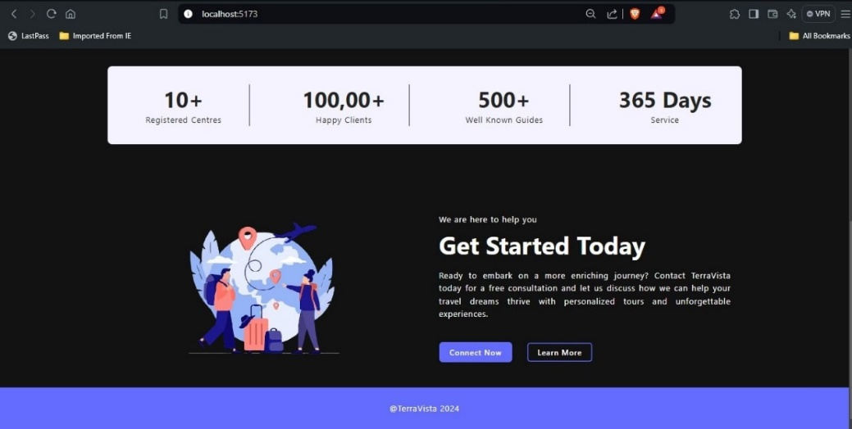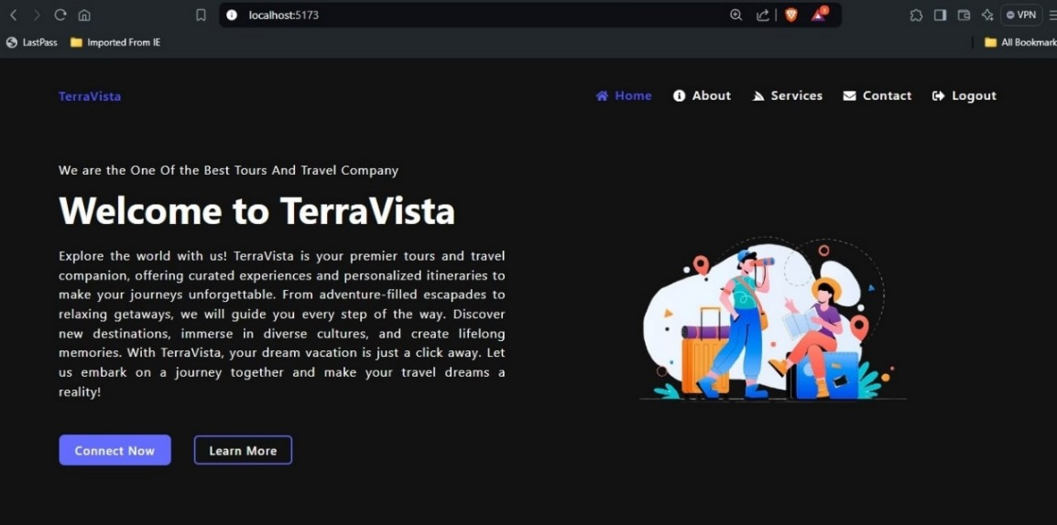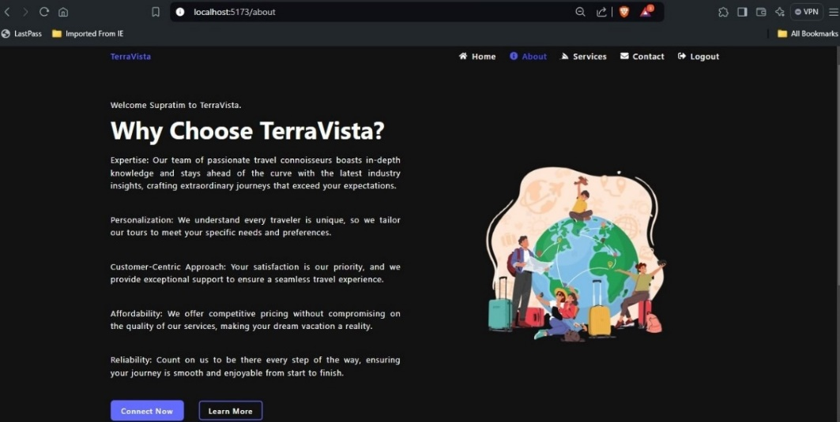**Home Page:** The homepage showcases featured tours, promotions, and a navigation bar for users to explore different services.
  2. **Tour Details Page:** A detailed view of a specific tour, including the itinerary, price breakdown, images, and an inquiry button.

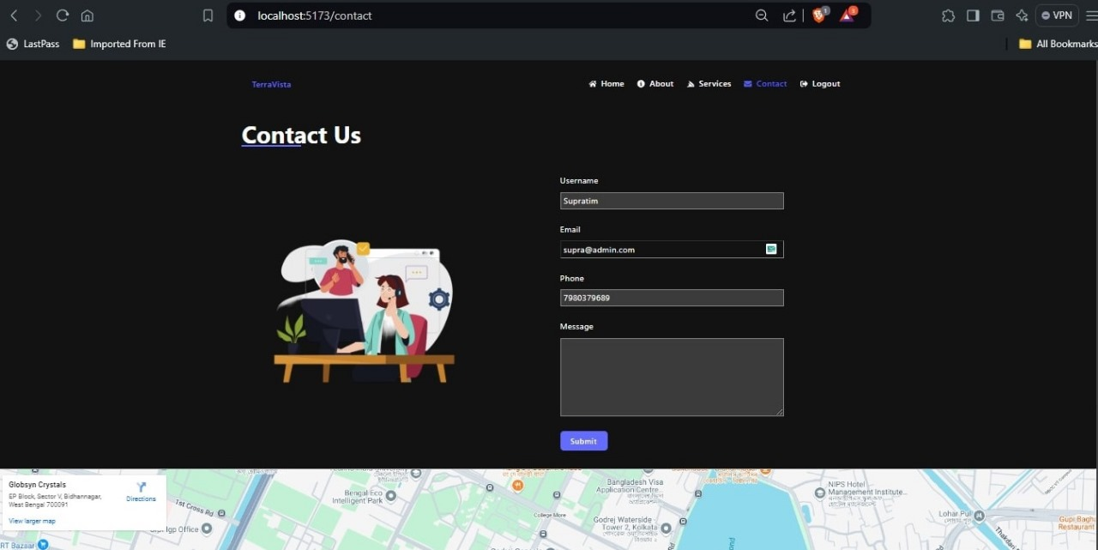

**7.3 Contact Form:** A simple, user-friendly contact form where users can submit inquiries, including name, email, phone number, and message.

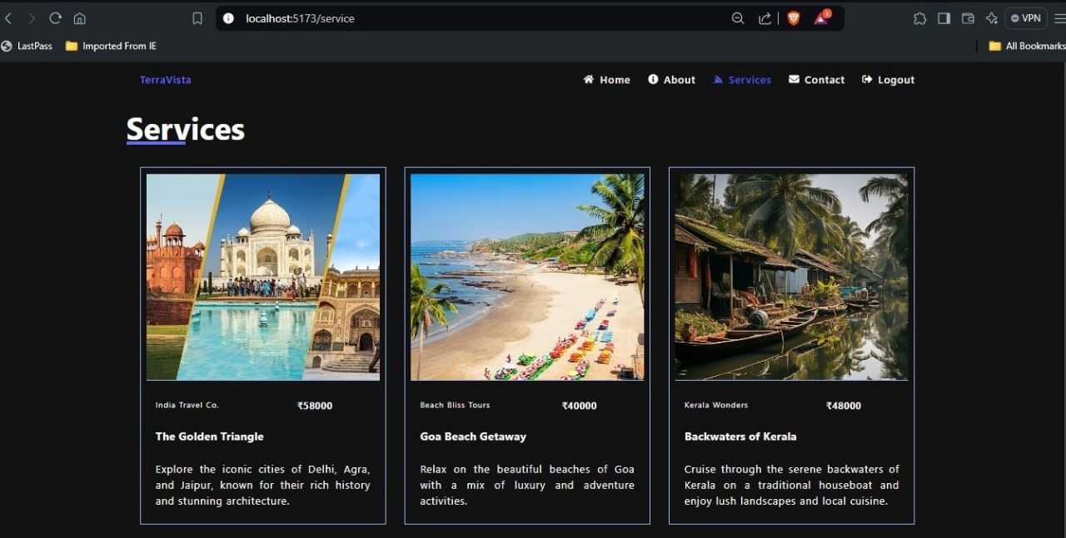

* 1. 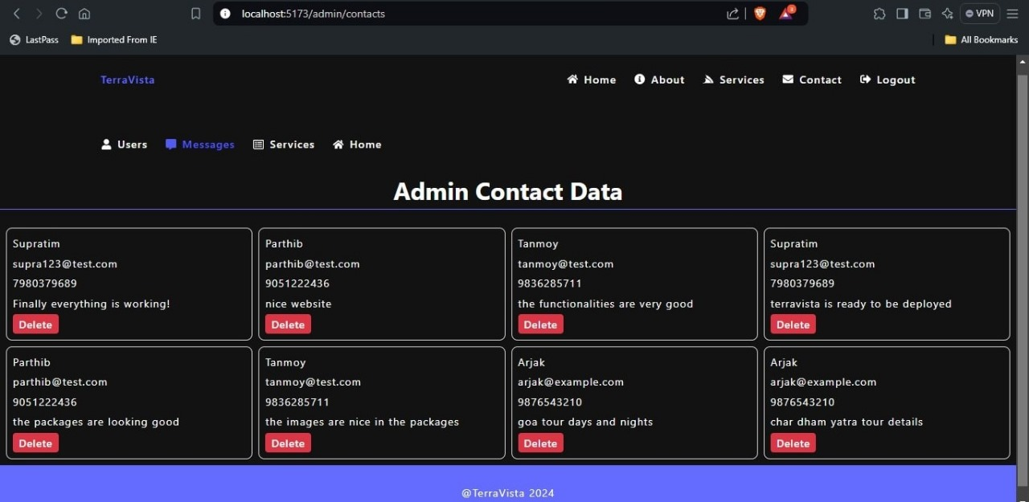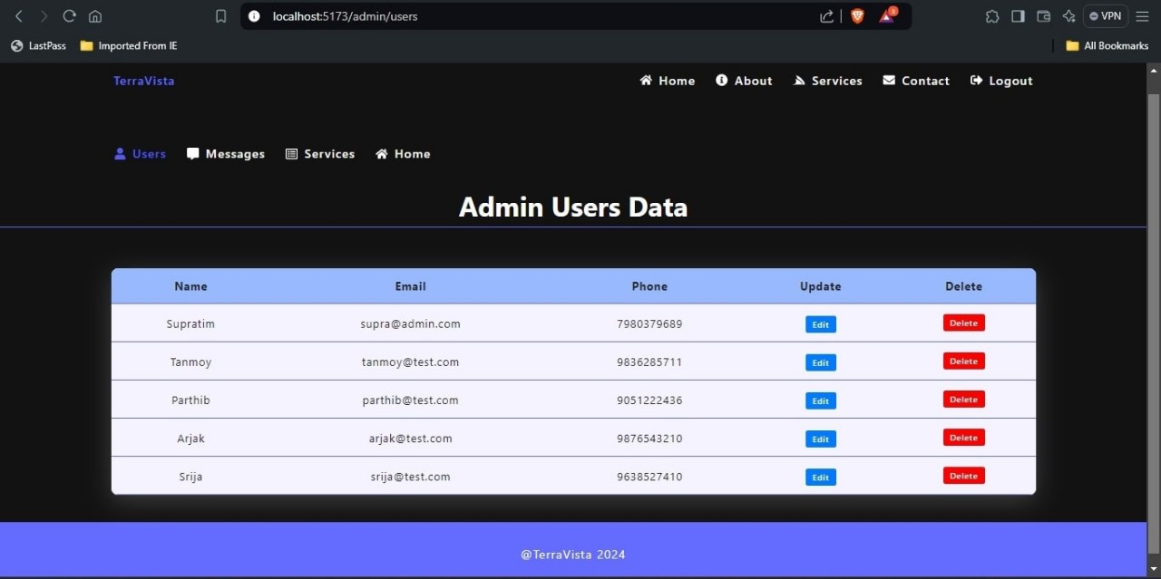**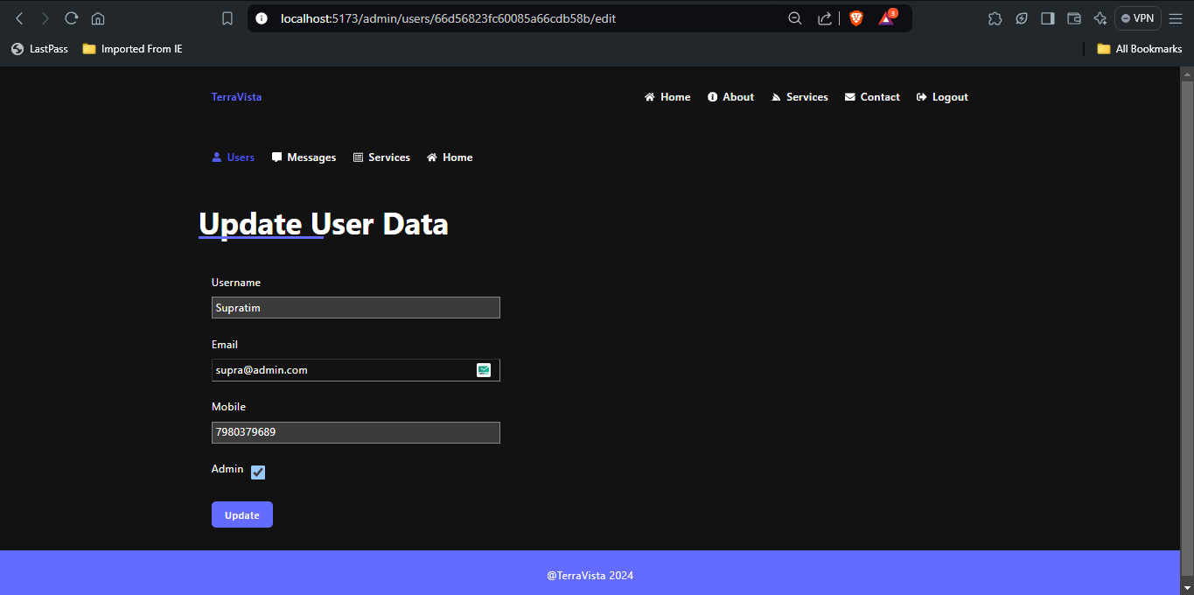Admin Dashboard:** The admin dashboard provides tools for managing services, uploading images, and reviewing user inquiries submitted via the contact form.
  2. 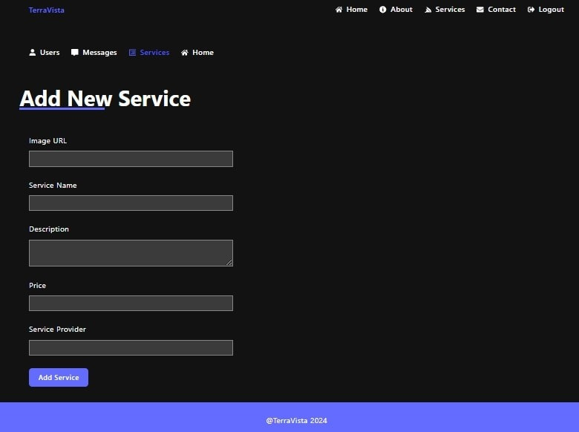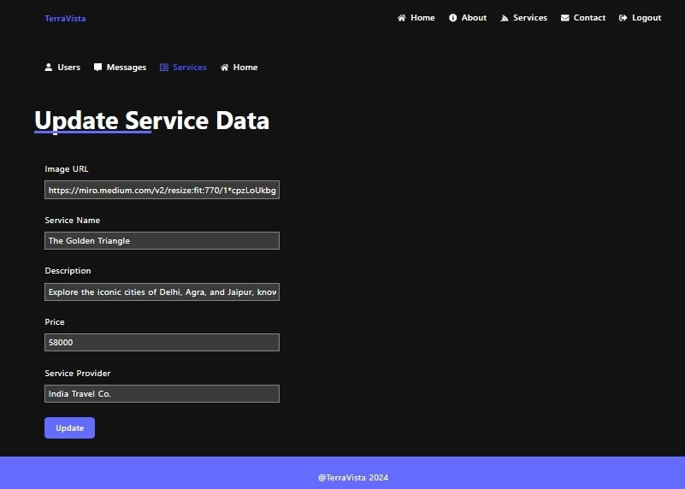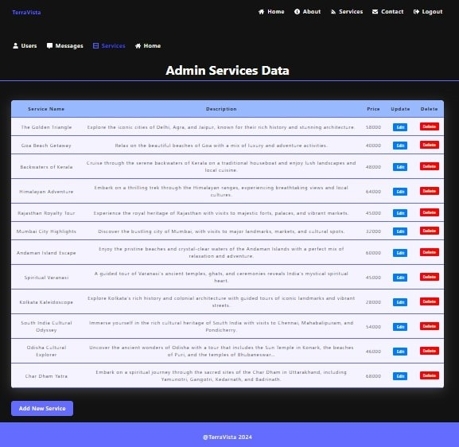 **Service Management:** A dedicated section for administrators to create, update, and delete services, complete with image uploads.
  3. **Login Page:** The login page allows registered users to securely log in using their email and password. It includes a link for password recovery.

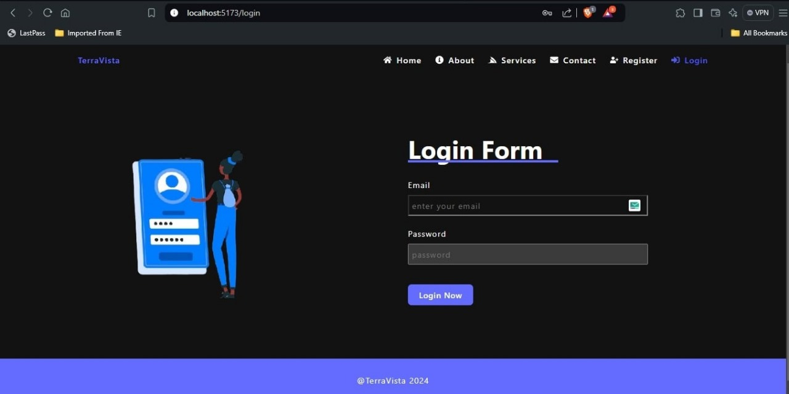

* 1. **Signup Page:** The signup page enables new users to register by providing their basic information (name, email, and password) and creating an account.

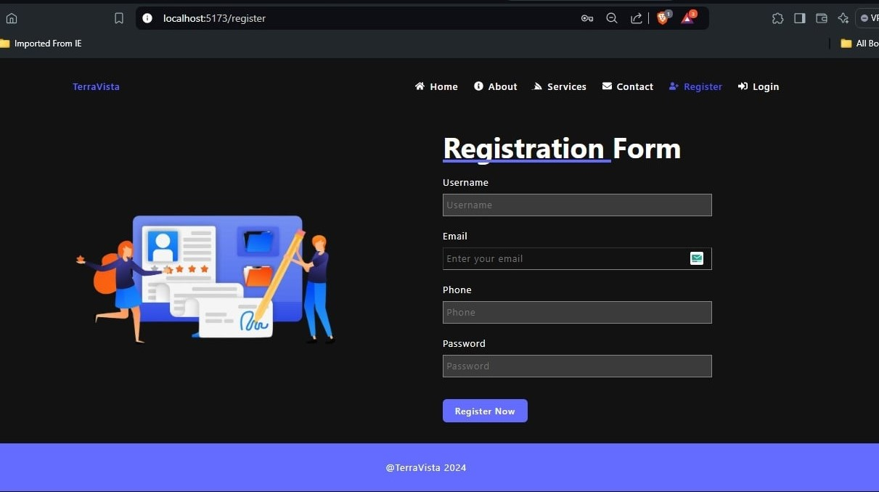

1. **CONCLUSION**

**TerraVista** represents a significant step forward in the realm of digital travel platforms, combining robust technology with a user-centric design to offer a comprehensive and engaging experience for both travellers and administrators. By leveraging the MERN stack, TerraVista ensures scalability, performance, and flexibility, meeting the demands of a growing user base and evolving market trends.

The platform's well-defined features, including an intuitive user interface, efficient admin tools, secure authentication mechanisms, and responsive design, collectively contribute to a seamless and effective travel booking experience. The inclusion of both user and admin functionalities ensures that the platform not only caters to the needs of travellers looking for diverse and detailed tour options but also empowers administrators with the tools necessary for effective service management and customer interaction.

With a focus on future growth and scalability, TerraVista is designed to adapt to emerging trends and expanding requirements. Its modular architecture allows for the incorporation of new features, ensuring the platform remains competitive and relevant in the evolving digital landscape.

In short, TerraVista is poised to make a meaningful impact in the travel industry by offering a reliable, user-friendly, and scalable solution for exploring and booking travel experiences. Its comprehensive feature set and strategic design choices position it as an asset for both users and administrators, supporting the platform’s mission to enhance travel experiences and streamline service management.